Resources for Siblings

Siblings with a Mission:
Representatives:
Siblings with a Mission is an international organization dedicated to serve and support siblings of individuals with special needs and their families. We offer support to both siblings and sibling supporters through an online story column where siblings and families can exchange stories and share insights with others, a resource center where families can connect with other organizations, and sibling workshops that we host around the country. We also have a chat and forum group where siblings can communicate with others. It’s all about supporting families and spreading hope, one story at a time. To learn more about Siblings with a Mission, please visit www.siblingswithamission.org. To become a member and receive our stories and updates, sign up for free by filling out the online form at http://www.siblingswithamission.org/become-a-member.html. Please “like us” on Facebook as well.
Join us on our mission today!

Manav Midha, Nathan Grant
Website: www.siblingswithamission.org
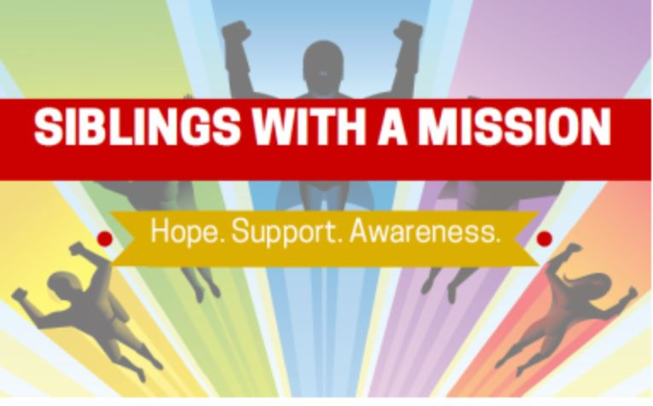

Sibling Leadership Network:

The Sibling Leadership Network (SLN) is dedicated to providing siblings of individuals with disabilities the information, support and tools to advocate with their brothers and sisters and to promote the issues important to them and their entire families. The SLN provides information and resources to help families of individuals with disabilities navigate the needs of all members across the lifespan, shares research findings related to siblings, and builds a passionate and informed community of advocates for better policies for people with disabilities and their loved ones. Founded in 2007, the SLN is a national nonprofit with state chapters committed to strengthening the voices of siblings of people with disabilities in the areas of services, policy and advocacy. For more information, visit www.siblingleadership.org.
Representatives:
Katie Arnold, Barbara Sapharas
Website: http://siblingleadership.org/
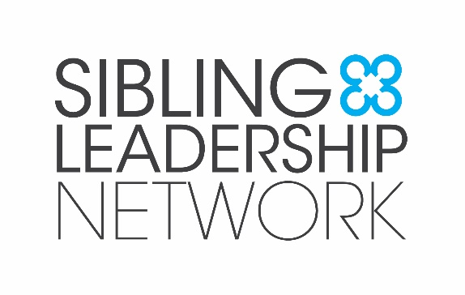

Sibling Support Project:
The Sibling Support Project is a national program dedicated to the life-long concerns of brothers and sisters of people who have special health, developmental, or mental health concerns. This organization provides many books and online groups for siblings in the special needs community.

Representative: Don Meyer

Website: http://www.siblingsupport.org/
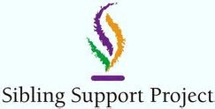

Ohio SIBS:
Representative:
It is the Mission of Ohio SIBS to be recognized as the unified voice and partner for Ohio adult siblings of people with developmental disabilities and their families. Ohio SIBS will provide advocacy, education, leadership and supports that will promote enhanced quality of life, improved public policy and increased services and supports for adult siblings (of people with developmental disabilities) and their families.
Deb Plaza
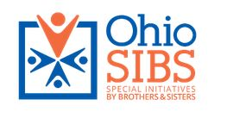
Website: http://ohiosibs.org/

A Kid Again improves the lives of families with children battling life-threatening illnesses. We give the entire family, including siblings, breaks from the illness through multiple, group outings each year to fun local venues such as Cincinnati Reds, Cincinnati Zoo, Holiday Party at Matthew 25: Ministries, Kings Island, and Scene 75 Arcade. Siblings are always welcome, even if the ill child is unable to attend. Siblings are treated the same as the sick children, including receiving gifts at our annual Holiday Party. Families may participate until the ill child turns 20 years old, with sibling participation also through age 20. The ongoing nature of the program gives the entire family events to look forward to together throughout each year and over the years, and families have regular opportunities to interact with other families who understand similar challenges.
A Kid Again:
Representative:
Liz Koszuta
Website: https://akidagain.org/

The Perlman Center (Ohio)
The Perlman Center is a specialty center at CCHMC designed to address the complex therapy, developmental, assistive technology and care coordination needs of children, youth and adults with cerebral palsy and other physically limiting conditions. Our comprehensive therapy and support programs focus on more than just your child. We believe your entire family is central to your child’s development and success, so we involve you and your family in your child’s care. Unlike conventional outpatient therapy, our therapy is designed to provide small groups of children with frequent and extended contact with a dedicated interdisciplinary team of occupational, physical and speech therapists − all in one environment. An early childhood specialist and a social worker complete our care team. The Perlman Center also offers Sibshops for siblings. Connect with us to learn more about our Sibshops!
Representative:
Jacqueline Rapose
Website:
www.cincinnatichildrens.org/service/a/aaron-perlman-center
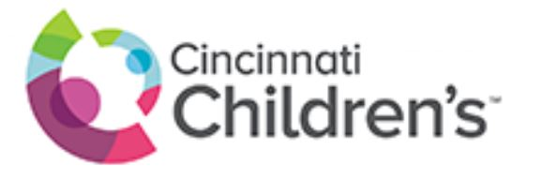

Clermont County DD (Ohio)
Representative:
The Clermont County Board of Developmental Disabilities is celebrating its 50th anniversary this year. Clermont DD serves children and adults who have developmental disabilities, ages birth through retirement. Their mission is to help those they serve expand capabilities and navigate the possibilities.
Lisa Davis
Website: http://clermontdd.org/
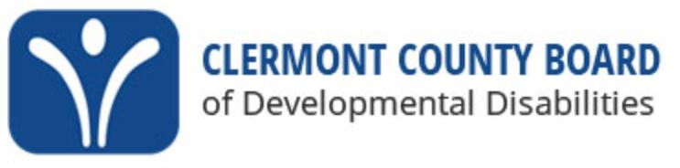

Families Connected of Clermont County (Ohio)
Families Connected of Clermont County is a grassroots family organization established in 1999 by parents/caregivers of children with disabilities to provide other parents and families information, resources, emotional support and guidance. The primary goal of Families Connected is to help all families become knowledgeable about systems and services which will empower them to make informed choices for their own families. Services provided include educational advocacy in the school system, Peer to Peer support for families who have children challenged by mental health and/or behavioral issues. Quarterly Sibshops are offered in collaboration with Child Focus, Inc., and resources to support families are available. Services are provided through contracts with agency providers, grants, donations, and volunteers.

Services are provided through contracts with agency providers, grants, donations, and volunteers.

Representatives: Julie Greger, Justina Pancake
Website:
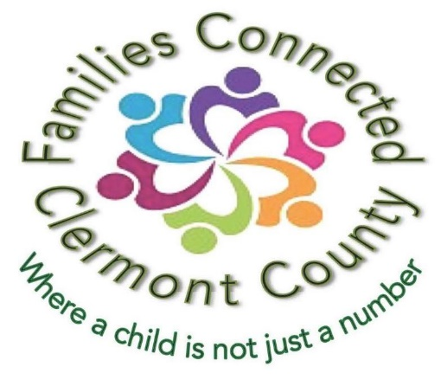
http://www.clermontcountyfamiliesconnected.org/

Hamilton County Developmental Disabilities Services (Ohio)
Representative: Lynne Calloway
Hamilton County Developmental Disabilities Services is a government social services agency established by state law. We support more than 7,300 people with intellectual and developmental disabilities throughout their lives, from babies through seniors, by providing case management, mo​nitoring service quality, and funding services provided by our community partners.
We treat each person we serve as a unique individual and connect them to services to reflect the life they want. By collaborating with more than 800 certified providers, we’re able to support people to live a life that is important and meaningful to them, on their own terms.

Website: http://hamiltondds.org/
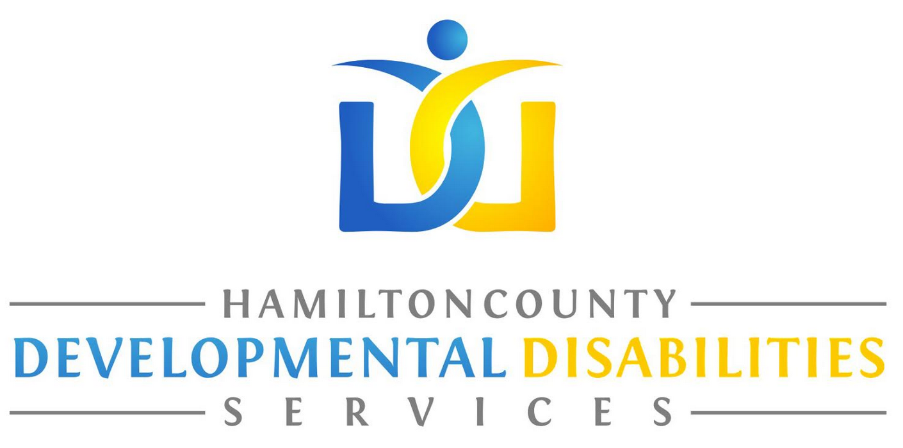

Dramakinetics (Ohio)
Dramakinetics of Cincinnati’s mission is to use drama, music and movement to spark self-determined creativity in all people so they can reach their full potential. Incorporated in 2007 as a 501c(3) non-profit corporation, DK prides itself on providing performing arts classes designed to include individuals of all abilities for recreational, academic, and therapeutic purposes. Dramakinetics is the benchmark of excellence in integrated arts and education programs in Greater Cincinnati, currently working with four different schools within the Cincinnati Public School district to incorporate the performing arts into daily curriculum in order to enhance the learning experience. Every lesson plan Dramakinetics uses has a focus on social emotional learning and 21st century skill building that are imperative for students today. We are excited to be a part of the Sibling Symposium and look forward to speaking with all of the drama and education lovers in attendance!
Representative:
Danielle Helton
Website: http://www.dramakinetics.org/
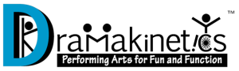

The University of Cincinnati Center for Excellence in Developmental Disabilities (UCCEDD) believes that people with disabilities should and can be active, included, and fully participating members of their communities. UCCEDD works with self-advocates, their family members, professionals, researchers, and policy makers to change perceptions and remove barriers for people with disabilities. UCCEDD is a leader in working with and on behalf of children and adults with disabilities and their families so they can lead the lives they want. UCCEDD accomplishes its mission through education, training, research, impacting on policy, and sharing information.
The Cincinnati LEND Program is part of a national network of 52 programs across the country. LEND programs share an overall mission of improving the health of infants, children, and adolescents with, or at risk for, neurodevelopmental and related disabilities including autism spectrum disorders (ASDs). A major focus of LEND is increasing the number of professionals with knowledge and skills to provide evidence-based screening, diagnosis, and treatment of developmental disabilities, including ASD. LEND trainees are individuals with disabilities, family members of individuals with disabilities, practicing professionals or graduate students. For more information, please email LENDTraining@cchmc.org or contact Dr. Stephanie Weber, LEND Training Director, at stephanie.weber@cchmc.org.

UCCEDD/LEND (Ohio)
Representatives:
Molly Sawyer, Sara Bitter
Website:
https://www.ucucedd.org/
